Low Level Design (PlAce order module)

Project Code | Team1
Project Name | E-Commerce(Online Shopping)

Prepared/Modified by | Role | Date of Preparation
Nidhi Shetty | Software Engineer | 16/12/2013
Reviewed by | Role | Date of Review
Mrunalee Kothari | Software Engineer | 17/12/2013
Approved by | Role | Date of Approval
Uma M Ponniamman | Training Manager
Circulation List | amit.agarwal@igate.com, mrunalee.kothari@igate.com, keerthi.parthasarathy@igate.com, nidhi.shetty@igate.com, nikeeta.menon@igate.com, shrikant.sutar@igate.com, bhagyashree.vedpathak@igate.com | Version Number of the template:1.0
Version Number | 1.3

Table of Contents

1. Description Of The Unit 3
2. References 4
3. Dependencies / Assumptions 5
4. Class Diagrams 6
5. Sequence Diagrams 7
6. Design Components 8
6.1 List Of UI Components 8
6.2 List Of Design Classes 8
7. Re-Usable Routines/Components 9
8. Messages 10
9. Configuration Files 11
10. Crud Matrix Table 12
11. Data Mapping Matrix 13
12. Action Flow Matrix 14
13. Stored Procedures 15
14. Program Specification / Pseudo Code 16
REVISION HISTORY OF THE WORK PRODUCT 17

Description Of The Unit

The place order module allows the customer of the application to confirm the order that he/she has placed. After the customer has placed the required orders in the application, the order data is taken from the cart and displayed on the place order page.

The customer can confirm the order upon which the customer is navigated to a page where the details of the order placed is displayed and the order details are inserted into the database.

The customer is also given the choice to cancel the order upon which the order is deleted from the cart and the customer is navigated to the home page.

References

Reference | Description
Repository reference | https://IGTEBLRSVNTNG.igatecorp.com/svn/oct3_Team1
Class Diagram | /Project Documents/Design Documents/HLD/Class Diagrams
URS | /Project Documents/Requirements/Case Study/Ecommerce-grp1 and grp3.doc
UTP | /Project Documents/Test Plan/UTP/Test Cases/ PlaceOrder/ Place Order Module.xls
DB Design | /Project Documents/Design Documents/HLD/DB Design/E-Commerce_GROUP_DBDESIGN.xls

Dependencies / Assumptions

Dependencies:
The place order module is dependent on Add to cart module.

Assumptions:
The customer should be logged in and the cart should not empty.

Class Diagrams

Class Diagram

Sequence Diagrams

Sequence Diagram
NA

Design Components

List Of UI Components
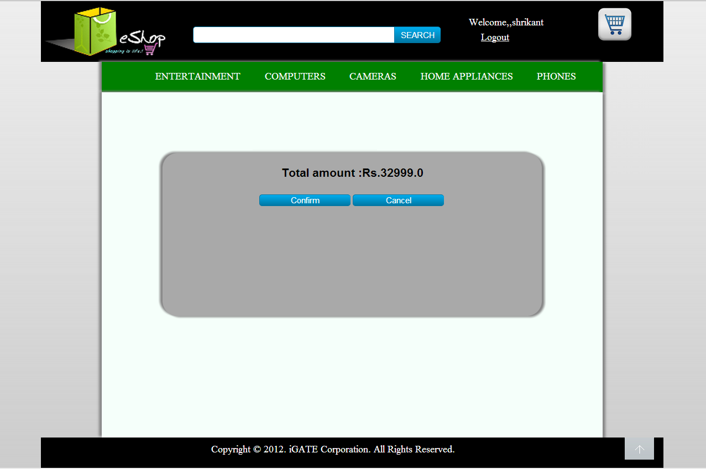

6.2 List Of Design Classes

Sr. No. | LLD Name | Class Name | Method Name | Method Description
1 | Place Order Module | Order | Appropriate getters and setters methods | Getters retrieve the property values and setters set the property values
2 | EcommerceDaoImple-  mentation | EshopController | preparePlaceOrder(Model model):String  processPlaceOrder(@RequestParam("SUBMIT") String submit,@RequestParam("totalAmount") String total,Model model):String  proceedToHomepage(Model model):String | Sets the model attribute.  Calls insertOrderDetails() of EshopBOImpl class.If it returns object, it gets redirected to a success page showing the order details.  Proceeds to the home page on clicking the cancel order button.
3 | EcommerceDaoImple-  mentation | EcommerceServiceImpl-  mentation | insertOrderDetails() :cartList<List>,double total,String userId | Calls insertOrderDetails() of EshopDAOImpl class class and returns the result to EshopController.
4 | EcommerceDaoImple-  mentation | EcommerceDaoImple-  mentation | insertOrderDetails() :cartList<List>,double total,String userId | Inserts the order details into the database and returns the result to EcommerceServiceImplementation

Re-Usable Routines/Components

Re-Usable Routines/Components

- CSS files
- Javascript files
- DataAccessException class
- Database properties files
- Logger properties files

Messages

#. | Type | Message Text
1 | NA | NA

Configuration Files

File Name | Path | Description
oracle.properties | /Development/Source | To configure database connection.
Web.xml | /Development/Source | To configure the bean properties.
Dispatcher-servlet.xml | /Development/Source | To configure the request mapping and view resolver.
Eshop_logger.properties | /Development/Source | To configure the logger.
Eshop_error.properties | /Development/Source | To configure error messages.

Crud Matrix Table

# | Table Name | Create | Read | Update | Delete
1. | Order | Y | Y | N | N

Data Mapping Matrix

Sr. No. | Screen Label | Field Source | Field Type | Data Type | Max Length | Data Flow | Mandatory
1 | Confirm | NA | Button | NA | NA | UI | NA
2 | Cancel | NA | Button | NA | NA | UI | NA

Legend
D → UI (Database to User Interface)
UI → D (User Interface to Database)
UI (User Interface Only)

Action Flow Matrix

Sr. No. | Action | Description | Process
1 | On click of confirm button in place order page | The order details are inserted into the database. | The customer clicks on the confirm button in the place order page and gets redirected to the page which displays the order details of the customer.
2 | On click of cancel button in place order page | The order details are not added into the database. | The customer is navigated to the home page and the order is canceled.

Stored Procedures

# | Stored Procedure Name  (with Description) | Input/Out Parameters | Type | Size
1. | NA | NA | NA | NA

Program Specification / Pseudo Code

<ACTION :CONFIRM_CLICK >

Pseudo Code:
- Client Side Scripting:
None

- Server Side Scripting:

BEGIN
Call processPlaceOrder(@ModelAttribute("Order") ,BindingResult result,Model model) in Controller class in Presentation Layer
BEGIN
Call insertOrderDetails(List<Product> cartList, double total, String userId)in EshopBOImpl class in Service Layer
BEGIN
Call insertOrderDetails(List<Product> cartList, double total, String userId) in EshopDAOImpl class in Data Access Layer
BEGIN
Create query for insert records into order table
Return Integer value.
END
Return Integer value. to Service Layer
END
Return Integer value to Presentation Layer
END
IF successful navigate to home page
Else navigate to error page and show error.
END

14. 2 <ACTION: CANCEL_CLICK>

Pseudo Code:

- Client Side Scripting:
None

- Server Side Scripting:
BEGIN
Call proceedToHomepage(Model model) in Controller class
Navigate to Home page
END

REVISION HISTORY OF THE WORK PRODUCT

# | Date | Version # | Section Changed | Details of changes made | Approved By
1 | 16/12/2013 | 1.0 | LLD prepared | N/A | Uma M Ponniamman
2 | 17/12/2013 | 1.1 | Reusable components,  Crude Matrix Table,Configuration Files. | Reusable components added.  The crud matrix table is modified.  More configuration files were added. | Uma M Ponniamman
3 | 18/12/2013 | 1.2 | Reusable components,  References, | Reusable Components added.  File name with relative path is added in the references section. | Uma M Ponniamman
4 | 24/12/2013 | 1.3 | Configuration files,UI Components | Paths of the configuration files is updated and UI components(Screen Shots) added. | Uma M Ponniamman

